Indian Institute of Technology, Kharagpur
Centre for Educational Technology

Mid Semester Examination 2014

Subject: INTRODUCTION TO DIGITAL SPEECH PROCESSING Code: ET60007

Time: 2:00 Hours PART-A:-10*2=20; PART-B:-5*6=30 Full Marks =50

Answer all the questions of PART-A and PART-B
(Please enclose the Annexure-1 along with the answer script)
PART-A
- What are the perceptual parameters of speech?

- Length of a vocal tract is 17.5cm and it model using single lossless acoustic tube. Derive the first three formant frequency and bandwidth for a voice sound. Where the speed of sound c=350m/s.

- Two source of speech signal producing a vowel /o/. The formant frequencies of the sources are differing by 3-4%. If a human being perceives the two sounds as same sound explains why this happen?
- 5 sec. speech segment is encoded using LPC coefficient and the LPC coefficient are extracted for each frame (frame length(L)= 5 pitch period) with a frame rate 100 frame/s. Determine the required order of the LPC analysis and how many frame’s LPC coefficient can be extract from the above speech signal. where the F₀ of the speech segment is 250 Hz and sampling frequency Fs=16 kHz

- Which of the following pair of tones is perceived as louder tone?
  - 25dB level at 500Hz and 25 db at 800 Hz (b) 5dB level at 7 KHz and 5dB level at 1 KHz
- Suppose an electric fan produces an intensity of 40 dB. How many times more intense is the sound of a conversation if it produces an intensity of 60 dB?

- Draw the glottal flow wave from and define the following
- Open phase, b) Closed phase and c) Period

- Describe the state of the Glottis during the pronunciation of the following phoneme?
/k/, /b/, /a/, /l/, /ʃ/
- Figure-1 represents the frequency analysis of a voice signal segment. Find out the value of F₀ of the voice signal
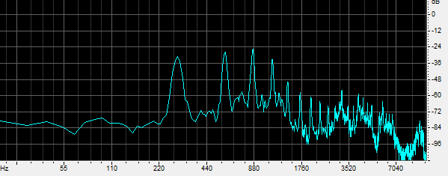
Figure-1
880 HZ

- Write the place and manner of articulation of the following phonemes?
/g^{h}/, /r/, /m/, /ɖ/

PART-B
- (a) Table 1 shows an F₁ and F₂ of the vowels of a language plot the vowels in F₁ and F₂ plane in Bark scale mark the axis intern of tongue height tongue position.
Table-1
Vowels | F₁ [Hz] | F₂[Hz]
/u/ | 325 | 1035
/o/ | 378 | 1025
/ɔ/ | 543 | 1019
/a/ | 866 | 1530
/æ/ | 591 | 1846
/e/ | 383 | 1978
/i/ | 309 | 2131

(b) What is equal loudness curve or phone curve? Draw an equal loudness curve for 10 dB

- (a) An analog signal x_{a}(t)=6sin(320πt)+4cos(820πt) is sampled at 600 Hz. Dertermine the F0 of the signal. How many sampled will be present in one fundamenal period?
(b) A discrete signal x[n]=6.35 cos(πn/5) is quantized with aresolution Δ=0.01. How many bits are required in A/D conversion?

- Linear prediction analysis is used to obtain a 6-order all-pole model for a segment of voiced speech that was sampled at a rate of F_{S} = 10000 Hz. Figure -1 shows the LPC spectrum of the above extracted LPC coefficient. Determine the root magnitude and root angle of the pole corresponding to first three formant. F₁=288Hz , F₂=719Hz, F₃,=2294Hz BW₁=92 Hz, BW₂=65Hz, BW₃=50Hz
F₂
F₁
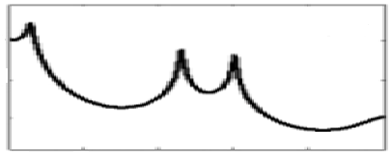
Frequency
BW₃
BW₂
BW₁
F₃
Figure-1
- (a) Figure-2 (a) and (b) in annexure-1 represents waveform and spectrogram of a VCV speech segment where C represent consonant and V represent Vowel. Mark the occlusion period, burst and VOT part? Write the manner of articulation of the consonant represented by the figure-2.
(b) Figure-3 in annexure-1 represent wideband spectrograms of a speech segment mark the following region your knowledge of acoustic phonetics i) voiced segment ii) unvoiced segment iii) any one consonant to vowel transition segment

- To produce a voiced speech signal of bandwidth 5 KHz how many section of lossless tubes are required. Where length of the tube is 17.5cm and c=35000cm/s. prove that one resonant frequency will be appear in every 1000Hz. Draw the digital equivalent circuit diagram of the above voiced speech signal production system where r_{g} is load at glottis and r_{l} is the radiation load.

Annexure-1

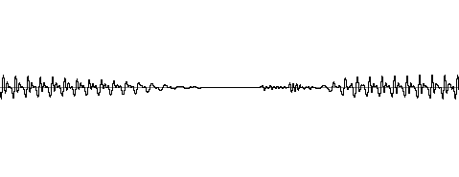
(a)

(b)
Figure-2

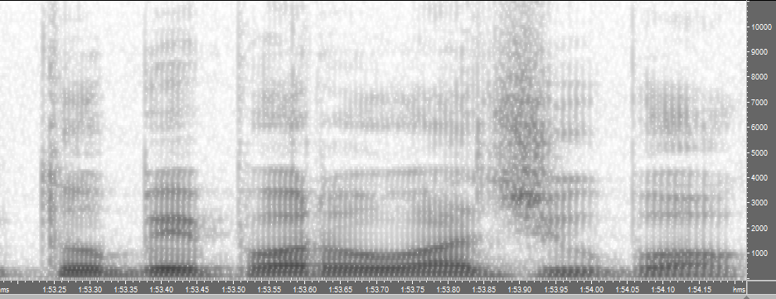
Figure-3

